Fig 1:

- Flowchart of Two-Stage Weapon Detection Model (training mode)

dfsdfsdfsdvxcvxcvxcvx

Calculate the average image dimensions
Input 1-Class Dataset
Train Yolov5s: RoI Detector
1st stage training weights file
Validate training & calculate metrics
Train ResNet-101: Classifier
Aligned images of objects
RoIAlign of object images
Final output: two stages training weights
Extract original bbox around objects
Object images of diff. size
2nd stage training weights file
Input multi-Class Dataset
Validate training & calculate metrics

Fig 2:

- Flowchart of Two-stage Weapon Detection Model (detection mode)

No
Yes
Input Image
Yolov5s: RoI Detector
bbox around objects
RoIAlign of objects’ bbox
ResNet-101: classifier
Aligned images of objects
K-means: refine bbox
Refined bbox around objects
Weapon?
Labeled and Localized weapon

Fig 3:
- Model structure a. model structure in training phase b. model structure in detection phase
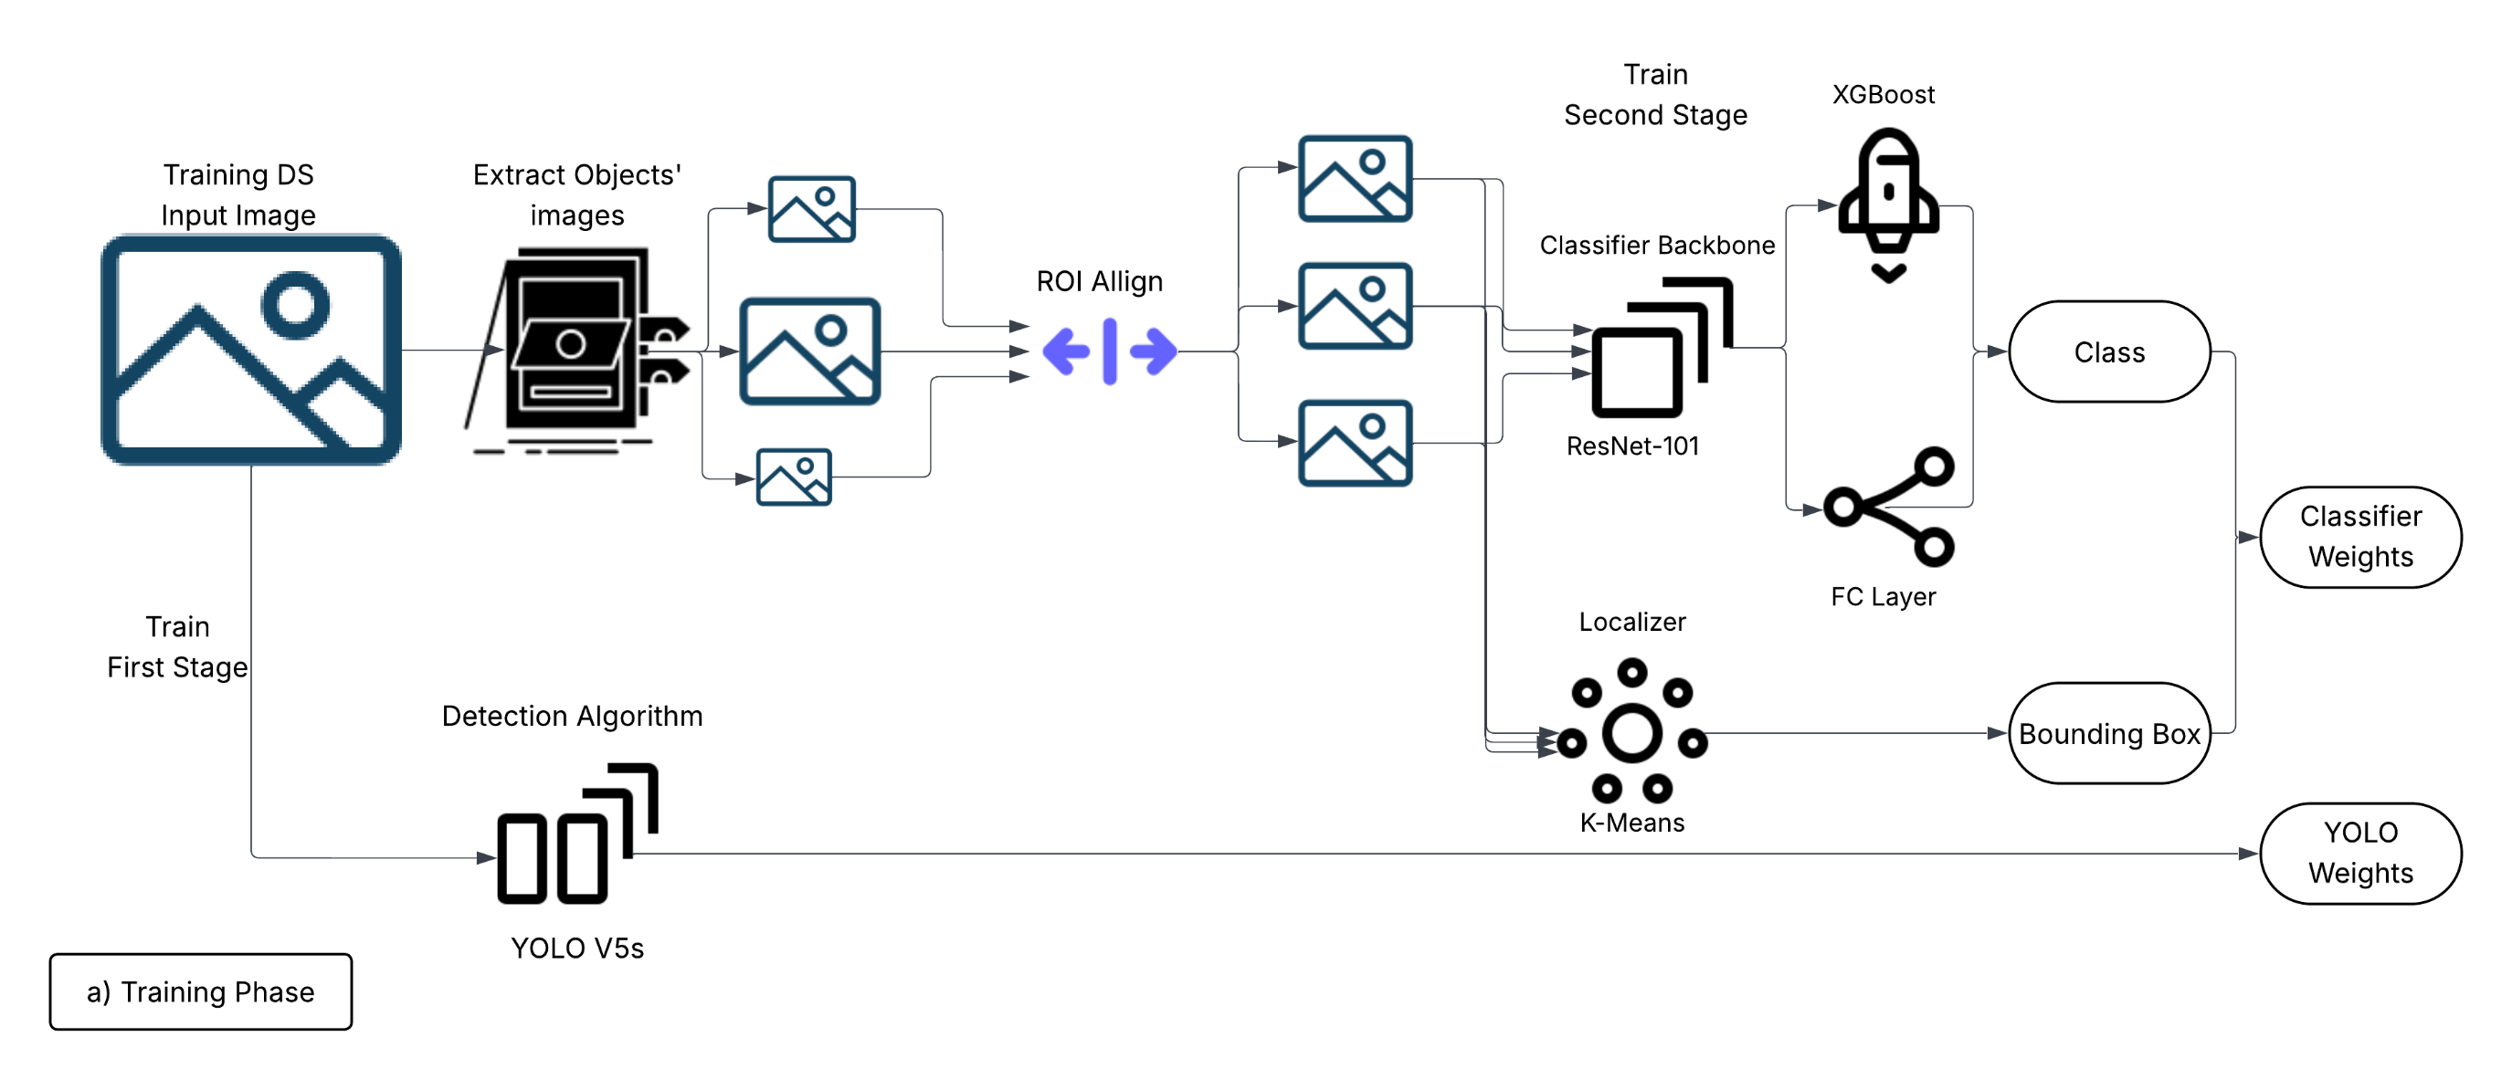
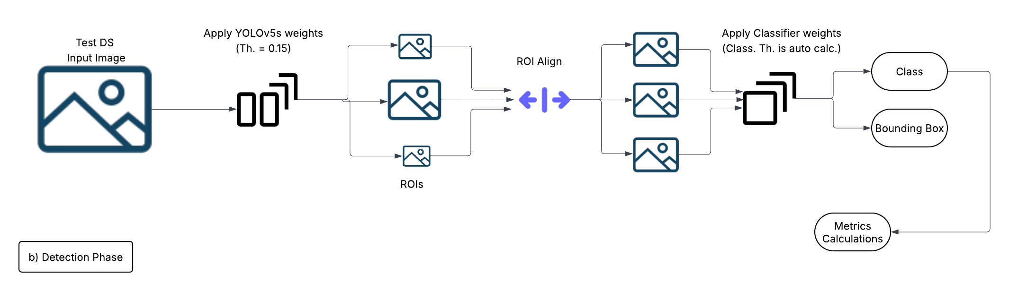

Fig 4:

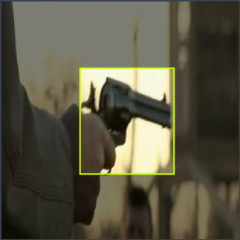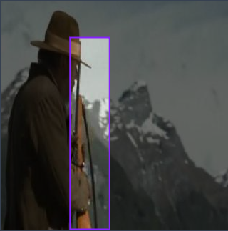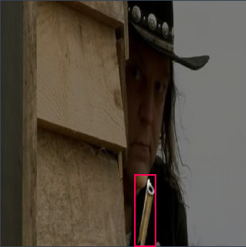
- Three samples images of our “Weapon” dataset representing classes (“Gun”, “LongGun”, “PartialGun”) respectivily

Fig 5:
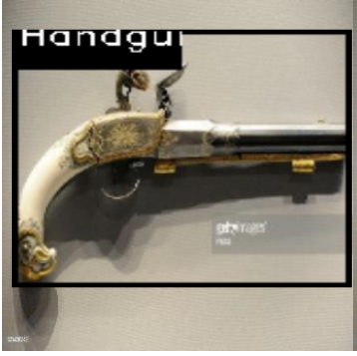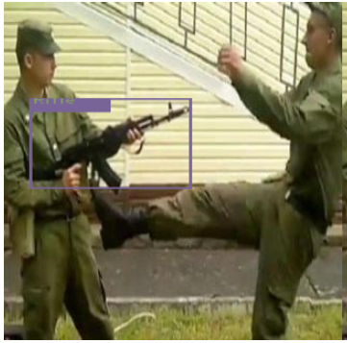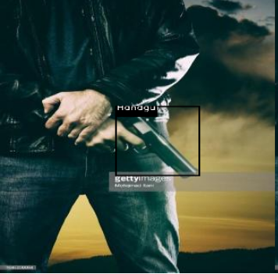

- Three sample images of “Weapon Classification” reference dataset representing classes (“Handgun”, “Rifle”,”Handgun”) respectivily

Fig 6:

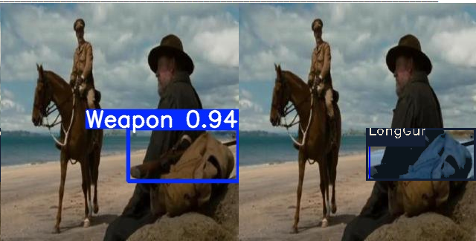 | LongGun
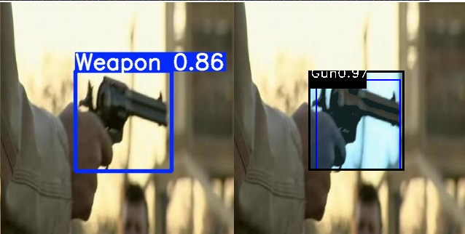 | Gun  & Enhance Localization
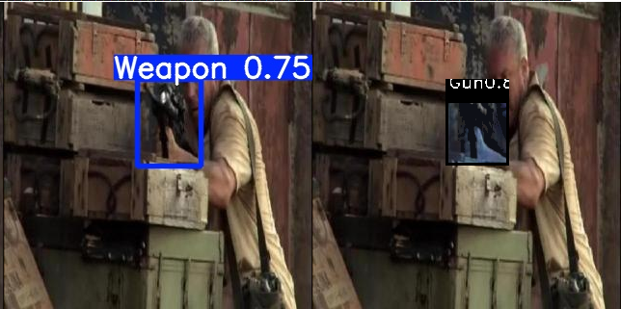 | Miss classify by 2nd stage
- Sample detections of proposed model on our “Weapon” dataset. We assume any missing classification is not counted as actual miss and is counted as weapon hit)

